UCD Pool & Snooker Club

Intervarsity Report

Pool Intervarsity’s

Birr, Co. Offaly 6th - 8th February 2009

This year's HESPC All Ireland Intervarsity Pool Championships saw 42 teams descend on the County Arms Hotel in Birr, Offaly to contend for the title. The attendance was a new record, with over 20 institutions represented and over 220 players.

Team Event

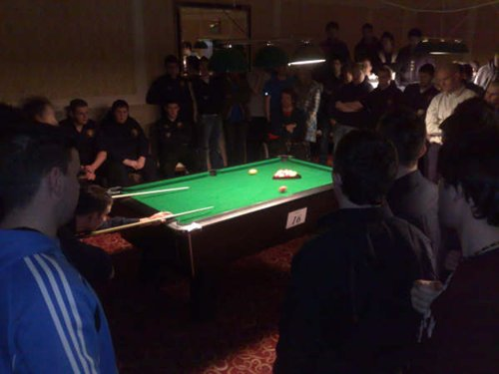
UCD sent 3 teams this year, 2 of which made it to the last 16 in the tournament. The UCD ‘A’ team came second in their group with convincing wins over UUJ ‘B’, GMIT and Tipperary IT only losing to Queens University Belfast ‘B’ team that narrowly edged out in front on frame difference to win the group.
Final Frame (Team Event)

The ‘B’ team recorded excellent wins over DCU ‘B’, NUIG ‘C’ and DIT ‘B’, losing only to WIT ‘A’. Despite this and as the standard was quite high in the group results favoured UCD ‘B’ and they finished the group stage on top of their group.

UCD ‘C’ had their work cut out from the start being in a group that had 3 ‘A’ teams, Trinity, NUI Maynooth and DIT. The other team in the group was Dundalk IT ‘B’. Unfortunately no wins were recorded by this years ‘C’ team.

In the end UCD ‘A’ lost out 6-2 to eventual semi-finalists DCU ‘A’. The UCD ‘B’ team were defeated by an excellent Waterford ‘B’ team. Had both UCD teams been victorious, they would have encountered each other in the quarter finals ensuring a UCD contingent in the semi-final!

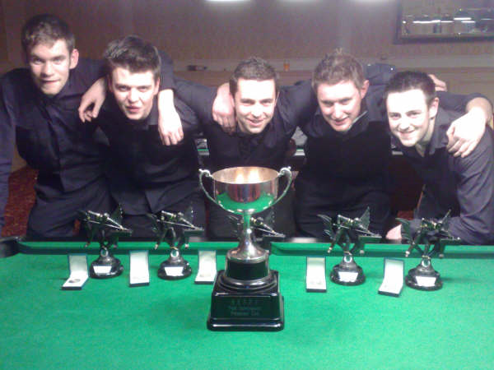

Dundalk IT "A" team finished the weekend as the NEW HESPC INTERVARSITY POOL CHAMPIONS. In defeating Queen's "A" 8-6 in the final, the team from Co. Louth won the title for the first time and are the thirteenth institution to have won the trophy.
Semi-finalists were holders UUC "A" (2-6 v Queen's) and DCU "A" (5-6 v Dundalk).

Intervarsity Pool Champions – Dundalk ‘A’
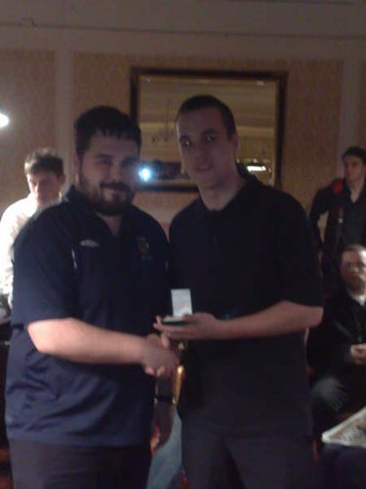
Singles Event
David Columb (Individual Winner)

As regards the singles event of the weekend, it was Kevin Cradden of the UCD ‘B’ team that managed to get the furthest of all 15 UCD players reaching the last 16 of 220 players. Other players that did well were; Steven O’Reilly – Last 32 (former semi-finalist, 2007), Patrick Lynam – Last 64 and Lorcan Kavanagh – Last 64.

David Columb of Dublin University (Trinity), who is known to quite a few players in the UPC and IPA circuits, won the Individual title by defeating Seamus Keane of NUI Galway in the final (4-1). Semi-finalists were Gareth Quinn (Queen's) and Gary Shields (DCU).

UCD’s Steven O’Reilly impressed at the event winning 17 of his 20 frames at the event and has earned himself a place on the Irish Intervarsity Home International Pool Team for the 2nd time in 3 years. The Home Internationals this year are being hosted in Dublin on the 17th and 18th of April.

UCD Pool & Snooker Club

Intervarsity Report

Snooker Intervarsity’s

Spawell, Co Dublin 28th - 29th November 2008

This years All Ireland Intervarsity Snooker Championships held in Spawell Snooker Club had over 8 Institutions represented with teams from UCD, DIT, DCU NUI Maynooth, IT Tallagh, UUJ, UUC and QUB.

Team Event

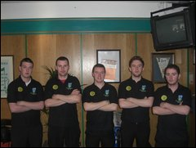
UCD provided 2 teams this year for the Snooker Intervarsity Competition with 9 of the 10 players coming from a pool background. Despite this the UCD ‘A’ team topped their group of 4 teams with 2 comfortable wins over IT Tallagh ‘A’ and NUI Maynooth ‘C’ and a narrow 6-4 win over Queens ‘B’ team. This sent the ‘A’ team into the next day with a place in the quarter finals. Unfortunately a victory in the quarter final wasn’t to be but even so it was somewhat of a small success on the behalf of UCD ‘A’ this year with the team narrowly missing out on a place in the semi-final. A draw of 5-5 with the DIT ‘A’ team yielded a 1 frame shootout involving UCD’s Steven O’Reilly and DIT’s James McDonald. Unfortunately after taking an early 40 point lead, Steven eventually lost the frame with breaks of 47 and 31 from James McDonald.
UCD 'A' Team (Quarter Finalists)
LtoR: Kevin Cradden, Brian McLean, Steven O’Reilly, Lorcan Kavanagh, Noel Conaty

The ‘B’ team performed well but unfortunately just missed out on qualifying for the quarter finals, finishing 3rd in their group of 4 teams.

In the end NUI Maynooth ‘A’ successfully defended their Intervarsity Snooker Championship Title with victory over Queen's Belfast ‘A’ in the team final. Mark McCabe, Tom McKeown and Jonny Williams recorded wins to secure the title.

Singles Event
The singles event portrayed a very high standard with many high breaks being notched up by the few likely suspects such as Johnny Williams (NUIM), Paul Ennis (DIT), Tom McKeown (NUIM) and UCD’s Steven O’Reilly knocking in 87, 51, 63 and 53 respectively along with many high 30 – 40 point breaks. The UCD contingent was strong in the early stages but only Steven made it past the last 32, eventually losing out 2-0 in the quarter finals against eventual runner-up Paul Ennis.

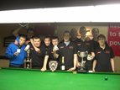
Eventually, last years runner-up, Jonny Williams, lifted the individual title, coming back from two frames down to beat Paul Ennis of DIT in the final. Defending champion Tom McKeown put up a valiant defence, eventually losing out to runner-up Paul Ennis in the semi-final.
Maynooth, with a clean sweep of the silverware, also won their third title of the weekend when NUIM ‘C’ defeated QUB ‘C’ team in the final of the Team Plate Competition.

On a final note, UCD’s Steven O’Reilly will captain the Irish Snooker Home International Team. The event will be hosted in Terry Griffiths’ Snooker Club, ‘The Match Room’, in Llanelli, Wales on the 3rd and 4th of April.
Johnny Williams (NUIM), Maynooth 'A' and 'C' Teams with the Individual, Team and Plate Trophies.

For more information and more detailed results, check out www.hespc.com

As President of the Pool & Snooker Club in UCD Steven believes that we, in a college of so many students, have great potential of returning to the winning ways of the not so distant past. The players emerging are of immense talent and in order to control and channel these talents measures must be taken to improve the on campus facilities available to members of UCD Pool & Snooker Club.

Over the past year, after taking over the running of the club in his 2nd year at UCD, he has been trying to get the ball rolling so to speak, on acquiring state of the art facilities for cue sports on campus. It is frustrating that the Snooker players have to go off campus and pay quite a lot of money for practice. Also the cost of running pool tournaments, due to the huge interest in the sports, is quite significant and so Steven believes that if better facilities were available such as pool tables and snooker tables for members at a reduced rate, that this cost could be decreased by a considerable margin and the club could expand and use its money in more productive and effective ways.

Steven proposes to obtain a space for at least two snooker tables and 4 supreme make pool tables that would be available to members only and revenue could be generated for the space by charging for the lights etc, making it in his eyes a great asset to UCD Sport. Many other colleges in the country have these facilities and quite clearly they are benefitting hugely from them by winning the Intervarsity competitions and subsequently having their students on National teams.

Another reason UCD must act in facilitating students of these particular sports is due to the fact that this year, Steven was deeply involved in the setting up of the Inter-College Leinster Pool League that will go National next year. As a consequence UCD Pool & Snooker Club has to play half these matches on campus with sub-standard conditions. Also the actual league finals will be hosted on campus in the trap this year and in order to keep this a permanent fixture Steven wishes to upgrade the facilities of the sport on campus so as to compete with the other colleges in the country.

